# Burak Kemal Kara - 2114734

# Hüseyin Bayrakdar - 2030294

# 1. Introduction

I2C is used for fast communication with multiple sensors. It uses two pins. Since TM4C123 doesn’t have DAC it uses external DAC. Sound recorded in 32kB Sram and send to DAC by using I2C.

# 2. Flowcharts

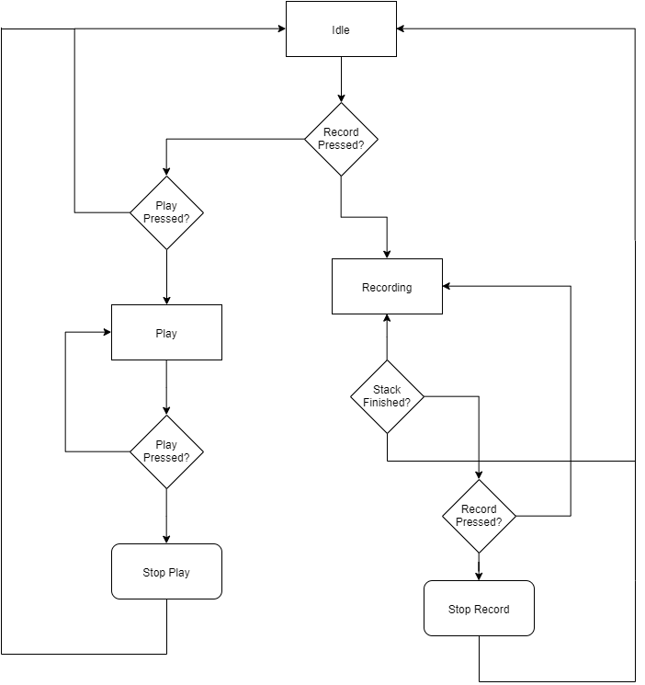

Figure 1 System FlowChart

System flowchart shown at Figure 1, In addition to this I2C flowchart is given separately at Figure 2. Recording consist of ADC unit. It is not complex since there is no flowchart for that.

A screenshot of a social media post

Description generated with very high confidence

Figure 2 I2C Flowchart

I2C initializations are given in source codes detailed. MTPR value taken from POT as integers. İt varies between 2-10. It makes sound faster or slower.At each loop we check Button if recording finished or continues.

# 3. Hardware Scheme

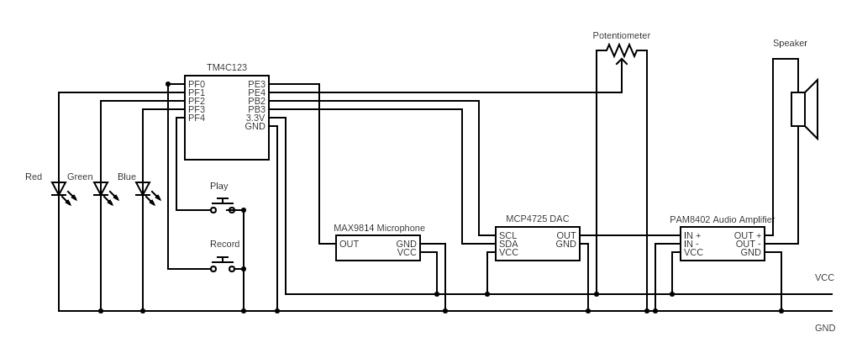

Figure 3 Hardware Scheme with port connections

# 4. Setup Photo

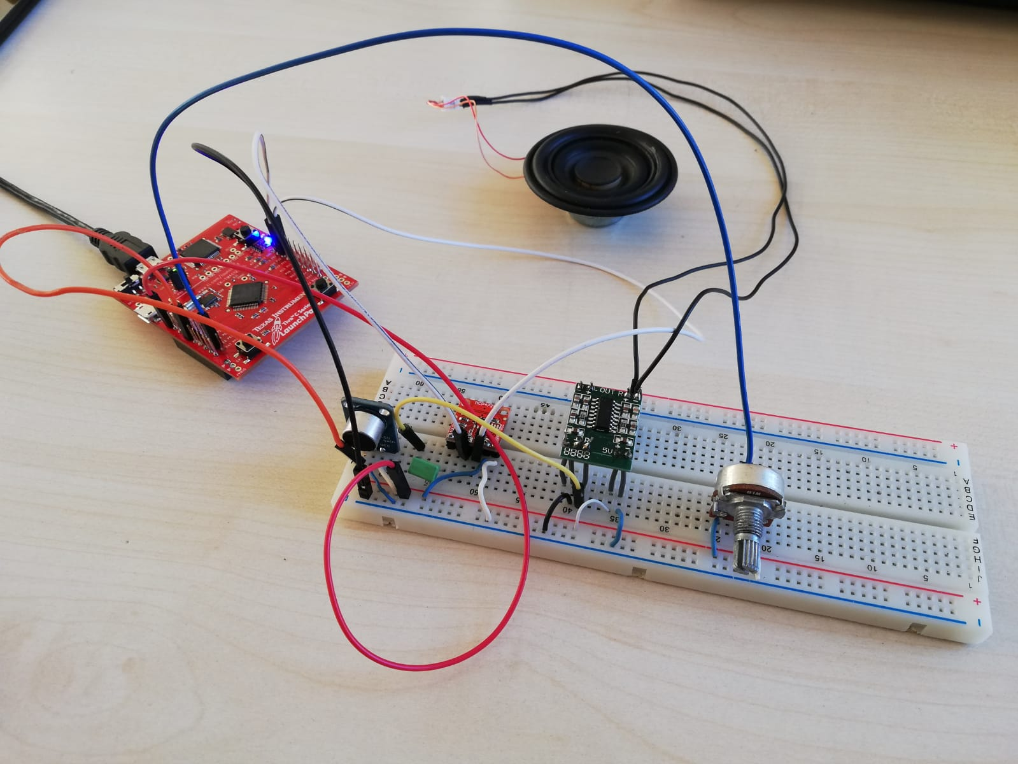

Figure 4 Setup Photo

Components of setup is same as given at Pre report except audio amplifier. Audio amplifier is PAM8402 which is stereo type of recommended audio amplifier.

## Utilities:

1. MAX9814 Microphone Module
2. MCP4725 I2C DAC Breakout Module
3. PAM8402A Stereo Audio Amplifier Module
4. TM4C123 Microcontroller
5. Breadboard
6. Speaker 3W
7. Potentiometer

# 5. Workload Chart

|  |  |  |
| --- | --- | --- |
|  | Burak Kemal Kara | Hüseyin Bayrakdar |
| Analog Circuit | * | ***** |
| Microphone adc | ***** | ** |
| POT adc | ***** | ** |
| Bonus part Logic | ***** | *** |
| I2C implementation | ***** | * |

# 6. Operational Description

Sampling: By using Timer module with ADC we sampling a signal. Timer period is arranged to adjust sampling 8 kHz. Result is 12 bit but we ignore LSB 4 bit. We have only byte for each sample. This gives an opportunity to have more storage.

I2C: Data send DAC package by package. It visualized at Figure 5.

|  |  |  |  |  |  |  |  |  |  |  |  |  |  |  |  |  |  |  |  |
| --- | --- | --- | --- | --- | --- | --- | --- | --- | --- | --- | --- | --- | --- | --- | --- | --- | --- | --- | --- |
| START | ACK | 0 | 0 | 0 | 0 | D7 | D6 | D5 | D4 | ACK | D3 | D2 | D1 | D0 | 0 | 0 | 0 | 0 | STOP |

Figure 5 I2C visualization

Since we send 8 bit instead of 12 bit LSB 4 bit is arranged as 0.

Bonus Feature: By polling we creates 3 state. At idle we check if play or record button pressed . Also we use leds note that we should unlock PF0 and PF4 to use these buttons.

# 7. Challenges

Sending byte with I2C is a real challenge for us. It is very hard to find right sequence. At first we didn’t know that DAC has EPROOM and DAC operation. We cant see any output at all. We gives almost 2 days to send sensible bytes. Than we use delay operation to adjust frequency of output but this doesn’t work. Than we use MTPR value and it works crystal clear. Second challenge is using PLL. We try to use but it doesn’t initiate so we use 16MHz clock again.

# 8. Conclusion

Simple Audio recording is modelled. This is very short recording since we have small storage. Even at this step we aware that audio has a lot of noise. In real this is not a commercial product because of its noisy characteristic. By using a low pass filter this sound will be prettier. But this also increase size. Overall it understood that even making a small, low noise recording unit is not an easy task because of its cost and size consideration.